U25AI055
Lab-2
Problem 1: Array Operations in C
Goal:
To understand the non-primitive data type Array and its operations. Write reusable functions for later use in the subject.
Tasks:
1. Array Creation: Create three signed integer arrays:
o SubArray1, SubArray2 of size 10.
o MainArray of size 20.
2. Operations: Implement a menu to perform the following operations on the arrays and
print the array elements after each operation:
o Insert elements at the end, beginning, and user-given position.
o Delete elements from the end, beginning, and user-given position.
o Reverse the array using:
▪ A temporary array to hold the result.
▪ In-place reversal (without a temporary array).
o Copy a sequence of elements from the subarray (SubArray1 or SubArray2) to
MainArray.
o Merge two sorted arrays in descending order.
o Display the sum of all array elements:
▪ Without recursion.
▪ Using recursion.
o Search the array for a user-given value.
o Separate the MainArray into sub-arrays for:
▪ Odd and even numbers.
▪ Positive and negative numbers.
// 1: a: Array operations in C
#include <stdio.h>
#include <stdlib.h>
void readArray(int mainArray[], int size);
void printArray(int mainArray[], int size);
int insertElement(int mainArray[], int size, int element, int position);
int deleteElement(int mainArray[], int size, int position);
void reverseArray(int mainArray[], int size);
void reverseArrayInPlace(int mainArray[], int size);
int addElements(int mainArray[], int size);
int addElementsRecursively(int mainArray[], int size);
void searchElement(int mainArray[], int size, int element);
int main()
{
int choice;
int mainArray[20], subArray1[10], subArray2[10];
int size;
int element, position;
printf("Enter number of elements: ");
scanf("%d", &size);
readArray(mainArray, size);
printArray(mainArray, size);
do
{
printf("\n1: Insert element at end\n");
printf("2: Insert element at beginning\n");
printf("3: Insert element at given position\n");
printf("4: Delete last element\n");
printf("5: Delete first element\n");
printf("6: Delete element at given position\n");
printf("7: Reverse array using temporary array\n");
printf("8: Reverse array without using temporary array\n");
printf("9: Display sum of all elements using recursion\n");
printf("10: Display sum of all elements without using recursion\n");
printf("11: Search element\n");
printf("Enter choice: ");
scanf("%d", &choice);
switch (choice)
{
case 1:
printf("Enter element: ");
scanf("%d", &element);
size = insertElement(mainArray, size, element, size);
printArray(mainArray, size);
break;
case 2:
printf("Enter element: ");
scanf("%d", &element);
size = insertElement(mainArray, size, element, 0);
printArray(mainArray, size);
break;
case 3:
printf("Enter element: ");
scanf("%d", &element);
printf("Enter position: ");
scanf("%d", &position);
size = insertElement(mainArray, size, element, position);
printArray(mainArray, size);
break;
case 4:
size = deleteElement(mainArray, size, size - 1);
printArray(mainArray, size);
break;
case 5:
size = deleteElement(mainArray, size, 0);
printArray(mainArray, size);
break;
case 6:
printf("Enter position: ");
scanf("%d", &position);
size = deleteElement(mainArray, size, position);
printArray(mainArray, size);
break;
case 7:
reverseArray(mainArray, size);
printArray(mainArray, size);
break;
case 8:
reverseArrayInPlace(mainArray, size);
printArray(mainArray, size);
break;
case 9:
printf("Sum of all elements is %d", addElements(mainArray, size));
break;
case 10:
printf("Sum of all elements is %d", addElementsRecursively(mainArray, size));
break;
case 11:
printf("Enter element to search: ");
scanf("%d", &element);
searchElement(mainArray, size, element);
break;
default:
printf("Invalid choice");
}
} while (choice >= 1 && choice <= 11);
return 0;
}
void readArray(int mainArray[], int size)
{
printf("Enter elements of array: ");
for (int i = 0; i < size; i++)
{
scanf("%d", &mainArray[i]);
}
}
void printArray(int mainArray[], int size)
{
printf("Elements of array are ");
for (int i = 0; i < size; i++)
{
printf("%d\t", mainArray[i]);
}
}
int insertElement(int mainArray[], int size, int element, int position)
{
for (int i = size - 1; i >= position; i--)
{
mainArray[i + 1] = mainArray[i];
}
mainArray[position] = element;
return size + 1;
}
int deleteElement(int mainArray[], int size, int position)
{
for (int i = position; i < 20; i++)
{
mainArray[i] = mainArray[i + 1];
}
return size - 1;
}
void reverseArray(int mainArray[], int size)
{
int temp[size];
for (int i = 0; i < size; i++)
{
temp[size - i - 1] = mainArray[i];
}
for (int i = 0; i < size; i++)
{
mainArray[i] = temp [i];
}
}
void reverseArrayInPlace(int mainArray[], int size)
{
int left = 0, right = size - 1;
while (left <= right)
{
int temp = mainArray[left];
mainArray[left] = mainArray[right];
mainArray[right] = temp;
left++;
right--;
}
}
int addElements(int mainArray[], int size)
{
int sum = 0;
for (int i = 0; i < size; i++)
{
sum += mainArray[i];
}
return sum;
}
int addElementsRecursively(int mainArray[], int size)
{
if (size == 0)
return 0;
return mainArray[size - 1] + addElementsRecursively(mainArray, size - 1);
}
void searchElement(int mainArray[], int size, int element)
{
int position, flag = 0;
for (int i = 0; i < size && flag == 0; i++)
{
if (mainArray[i] == element)
{
position = i;
flag = 1;
}
}
if (flag == 1)
{
printf("Element was found at %d\n", position);
}
else
{
printf("Element was not found\n");
}
}
Output:
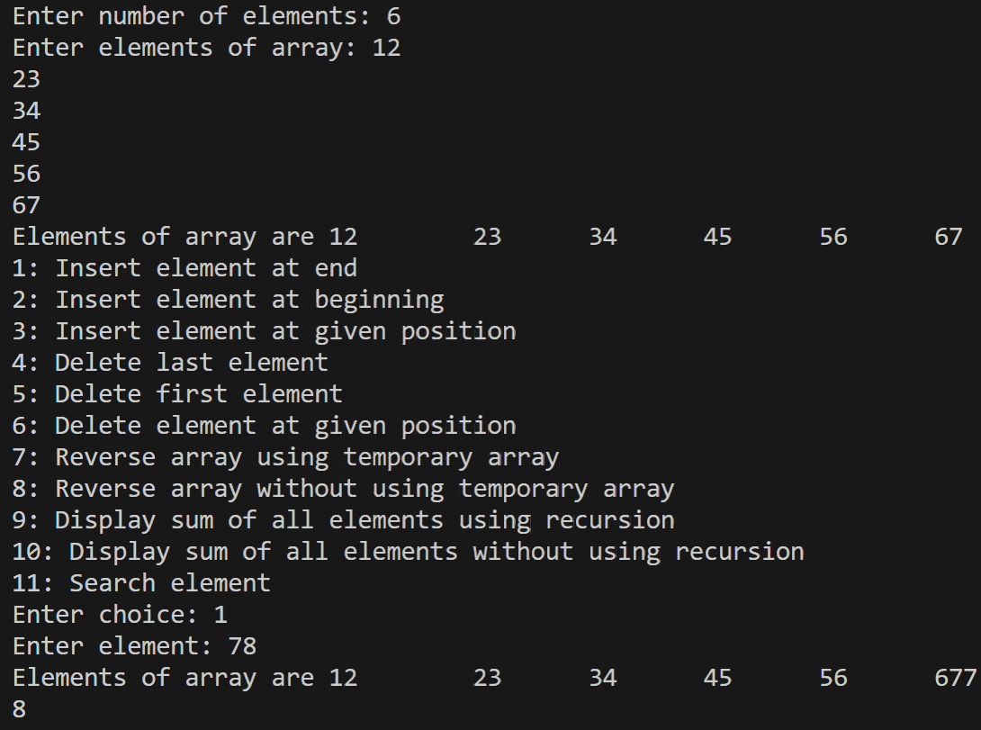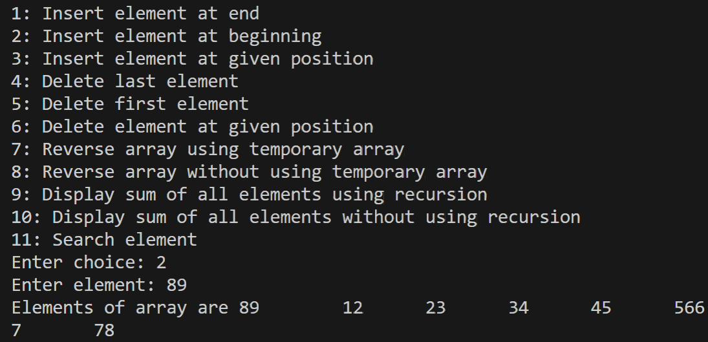
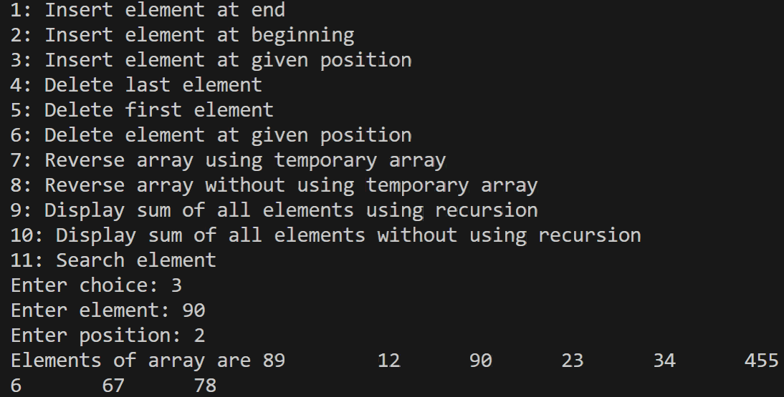
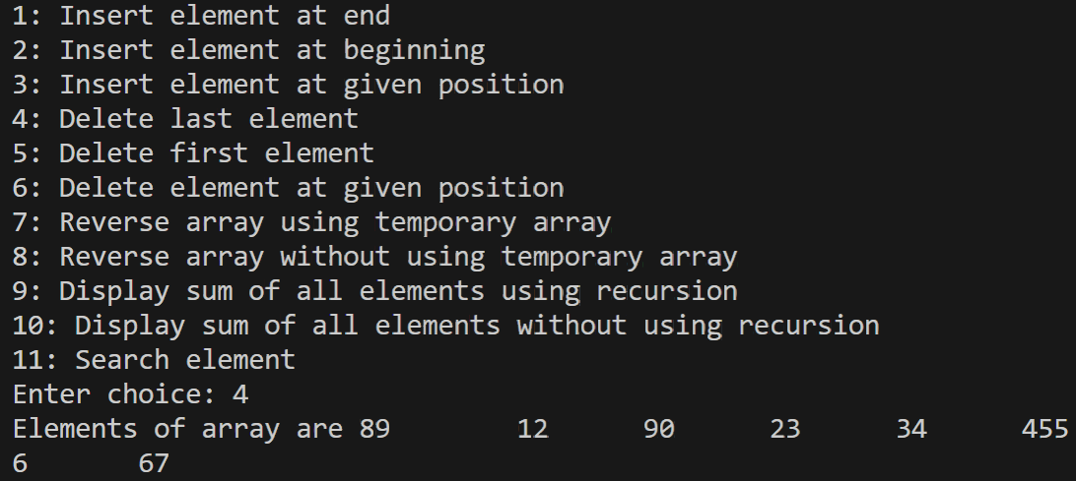
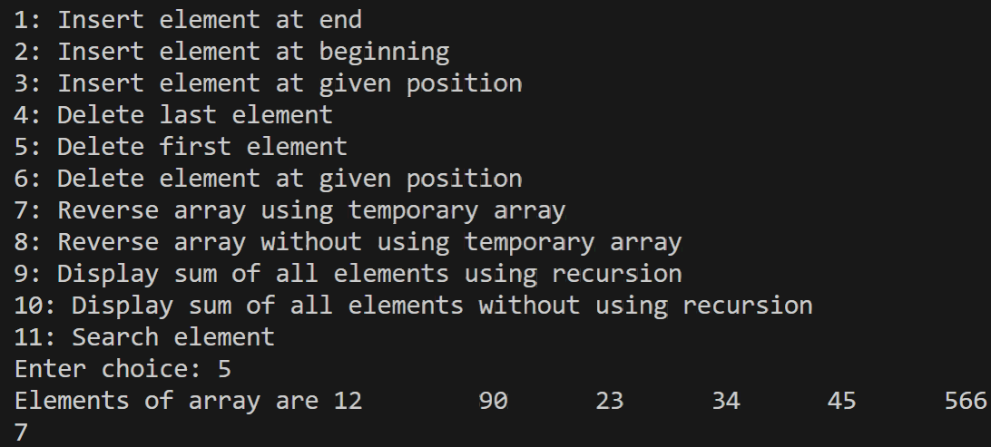
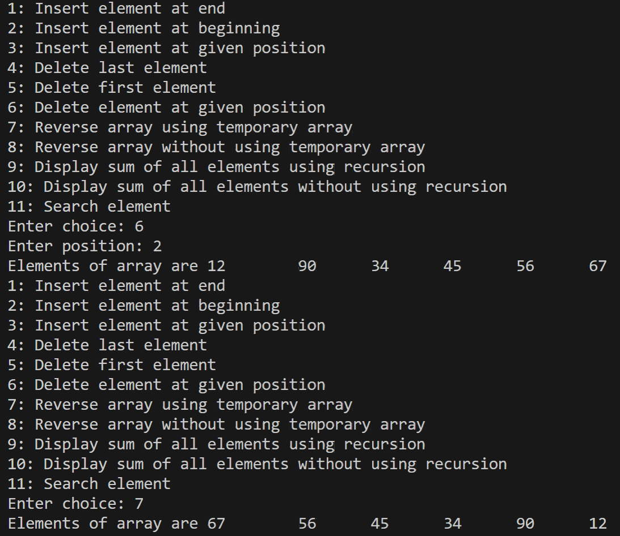
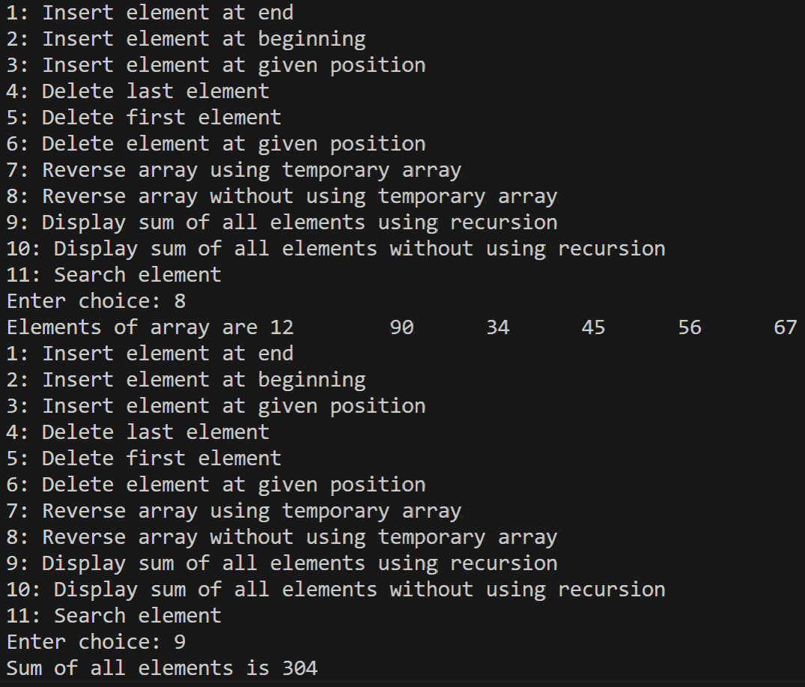
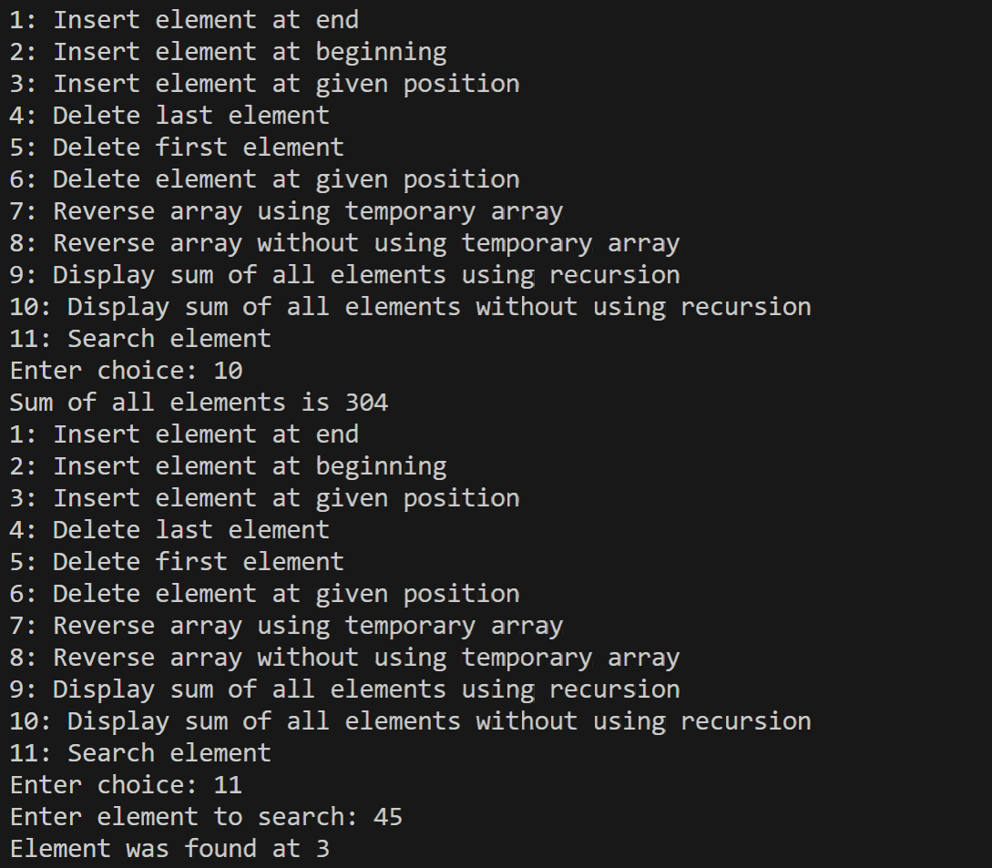
// 1: b: Array operations in C
#include <stdio.h>
#include <stdlib.h>
void readArray(int mainArray[], int size);
void printArray(int mainArray[], int size);
void copySubArray(int mainArray[], int subArray[]);
void mergeArrays(int mainArray[], int subArray1[], int subArray2[]);
void separateEvenAndOdd(int mainArray[], int size, int subArray1[], int subArray2[]);
void separatePositiveAndNegative(int mainArray[], int size, int subArray1[], int subArray2[]);
int main()
{
int choice;
int mainArray[20], subArray1[10], subArray2[10];
int size;
do
{
printf("\n1: Copy sub array\n");
printf("2: Merge two arrays\n");
printf("3: Separate even and odd numbers\n");
printf("4: Separate positive and negative numbers\n");
printf("Enter choice: ");
scanf("%d", &choice);
switch (choice)
{
case 1:
printf("Enter elements of sub array: ");
readArray(subArray1, 10);
printf("Elements of sub array are ");
printArray(subArray1, 10);
copySubArray(mainArray, subArray1);
printf("\nElements of main array are ");
printArray(mainArray, 10);
break;
case 2:
printf("Enter elements of sub array 1: ");
readArray(subArray1, 10);
printf("Elements of sub array 1 are ");
printArray(subArray1, 10);
printf("\nEnter elements of sub array 2: ");
readArray(subArray2, 10);
printf("Elements of sub array 2 are ");
printArray(subArray2, 10);
mergeArrays(mainArray, subArray1, subArray2);
printf("\nElements of main array are ");
printArray(mainArray, 20);
break;
case 3:
printf("Enter number of elements: ");
scanf("%d", &size);
printf("Enter elements of main array: ");
readArray(mainArray, size);
printf("Elements of main array are ");
printArray(mainArray, size);
separateEvenAndOdd(mainArray, size, subArray1, subArray2);
break;
case 4:
printf("Enter number of elements in main array: ");
scanf("%d", &size);
readArray(mainArray, size);
printArray(mainArray, size);
separatePositiveAndNegative(mainArray, size, subArray1, subArray2);
break;
default:
printf("Invalid choice\n");
}
} while (choice >= 1 && choice <= 4);
return 0;
}
void readArray(int mainArray[], int size)
{
for (int i = 0; i < size; i++)
{
scanf("%d", &mainArray[i]);
}
}
void printArray(int mainArray[], int size)
{
for (int i = 0; i < size; i++)
{
printf("%d\t", mainArray[i]);
}
}
void copySubArray(int mainArray[], int subArray[])
{
for (int i = 0; i < 10; i++)
{
mainArray[i] = subArray[i];
}
}
void mergeArrays(int mainArray[], int subArray1[], int subArray2[])
{
int temp, j, i = 0;
for (j = 0; j < 10; j++)
{
mainArray[i] = subArray1[j];
i++;
}
for (j = 0; j < 10; j++)
{
mainArray[i] = subArray2[j];
i++;
}
for (i = 0; i < 20; i++)
{
for (j = i + 1; j < 20; j++)
{
if (mainArray[i] < mainArray[j])
{
temp = mainArray[i];
mainArray[i] = mainArray[j];
mainArray[j] = temp;
}
}
}
}
void separateEvenAndOdd(int mainArray[], int size, int subArray1[], int subArray2[])
{
int j = 0, k = 0;
for (int i = 0; i < size; i++)
{
if (mainArray[i] % 2 == 0)
{
subArray1[j] = mainArray[i];
j++;
}
else
{
subArray2[k] = mainArray[i];
k++;
}
}
printf("\nEven numbers in sub array 1 are ");
for (int i = 0; i < j; i++)
{
printf("%d\t", subArray1[i]);
}
printf("\nOdd numbers in sub array 2 are ");
for (int i = 0; i < k; i++)
{
printf("%d\t", subArray2[i]);
}
}
void separatePositiveAndNegative(int mainArray[], int size, int subArray1[], int subArray2[])
{
int j = 0, k = 0;
for (int i = 0; i < size; i++)
{
if (mainArray[i] > 0)
{
subArray1[j] = mainArray[i];
j++;
}
else if (mainArray[i] < 0)
{
subArray2[k] = mainArray[i];
k++;
}
}
printf("\nPositive numbers in sub array 1 are ");
for (int i = 0; i < j; i++)
{
printf("%d\t", subArray1[i]);
}
printf("\nNegative numbers in sub array 2 are ");
for (int i = 0; i < k; i++)
{
printf("%d\t", subArray2[i]);
}
}
Output:
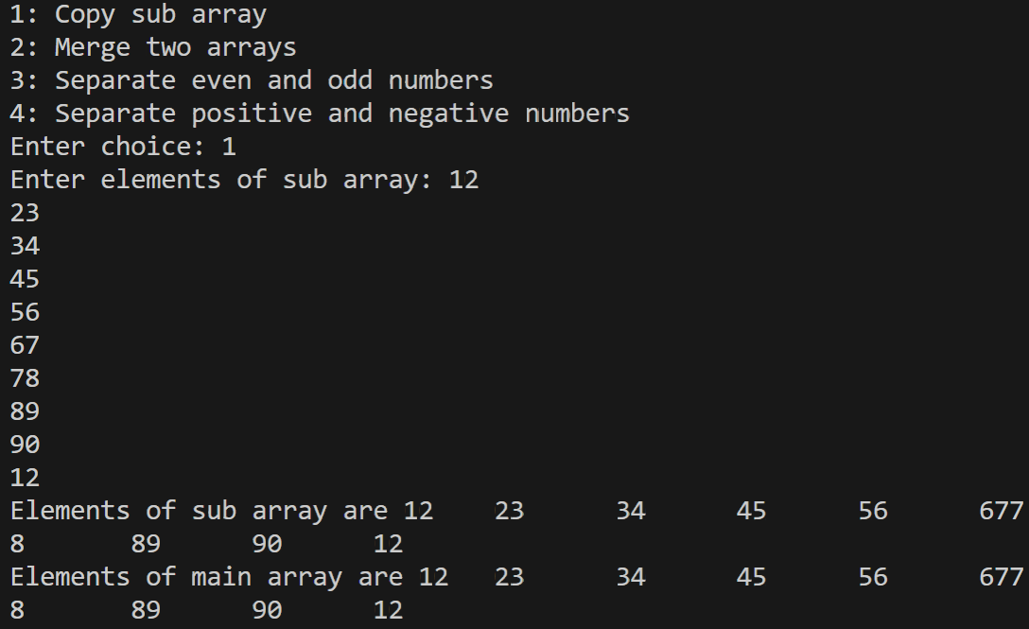
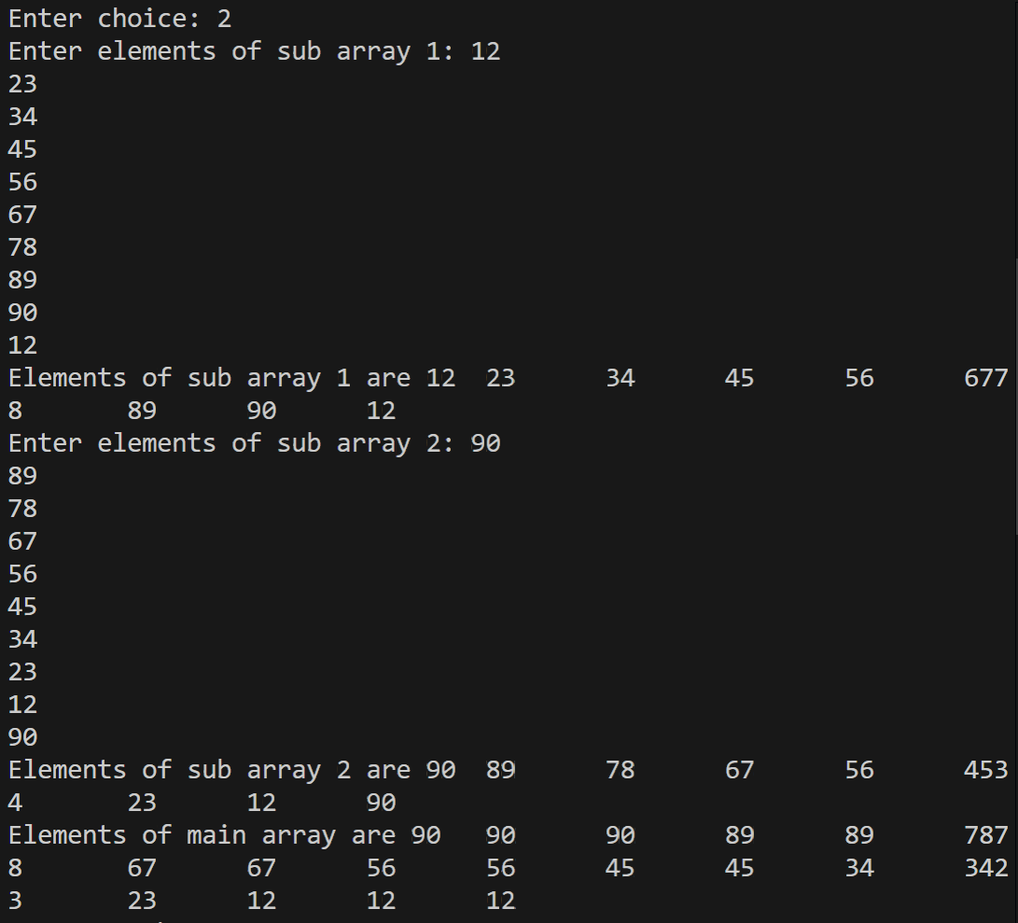
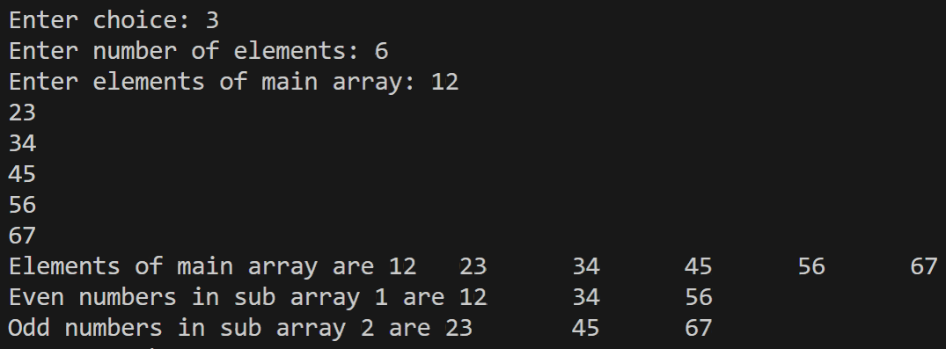
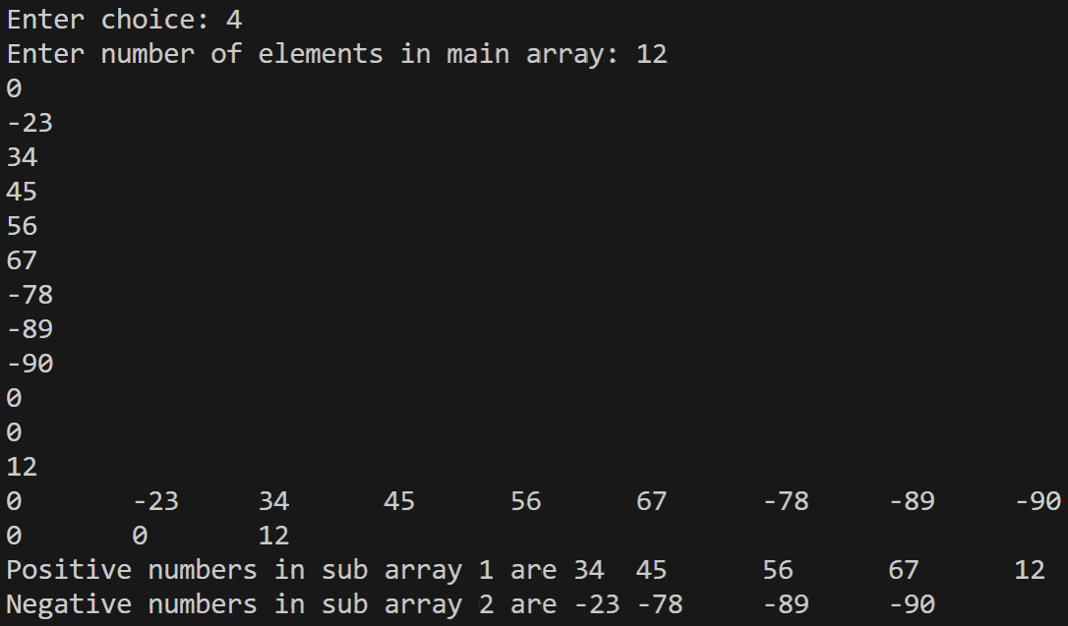
Problem 2: Design a Calendar
Goal:
Design a calendar for a given month and year using arrays to store:
● The names of the days of the week.
● The names of the months.
● The number of days in each month.
Task:
● Implement a C program to display the calendar for any given month and year.
// 2: Design a calendar
#include <stdio.h>
int main()
{
int year, month;
char daysOfWeek[7][10] = {"Mon", "Tue", "Wed", "Thu", "Fri", "Sat", "Sun"};
char monthsInYear[12][10] = {"January", "February", "March", "April", "May", "June", "July", "August", "September", "October", "November", "December"};
printf("Enter year: ");
scanf("%d", &year);
printf("Enter month: ");
scanf("%d", &month);
int reference = 1990, totalDays = 0;
for (int i = reference; i < year; i++)
{
if (i % 4 == 0)
{
totalDays += 366;
}
else
{
totalDays += 365;
}
}
for (int i = 1; i < month; i++)
{
switch (i)
{
case 2:
if (year % 4 == 0)
{
totalDays += 29;
}
else
{
totalDays += 28;
}
break;
case 1: case 3: case 5: case 7: case 8: case 10: case 12:
totalDays += 31;
break;
default:
totalDays += 30;
}
}
int start = totalDays % 7, row, column, date = 1, days;
switch (month)
{
case 2:
if (year % 4 == 0)
{
days = 29;
}
else
{
days = 28;
}
break;
case 1: case 3: case 5: case 7: case 8: case 10: case 12:
days = 31;
break;
default:
days = 30;
}
printf("%s, %d\n", monthsInYear[month - 1], year);
for (int i = 0; i < 7; i++)
{
printf("%s\t", daysOfWeek[i]);
}
printf("\n");
for (column = 0; column < 7 && date <= days; column++)
{
if (column < start)
printf(" \t");
else
{
printf("%3d\t", date);
date++;
}
}
printf("\n");
for (row = 1; date <= days; row++)
{
for (column = 0; column < 7 && date <= days; column++)
{
printf("%3d\t", date);
date++;
}
printf("\n");
}
return 0;
}
Output:
